Anabela Petrushevikj
D213 Pa Task 1
January 3, 2026
Professor Sewell

Part I:
A.
A1. How effectively can an ARIMA-based time series model capture short-term patterns in daily hospital revenue, and what insights do the resulting forecasts provide for operational and financial planning?
A2. This analysis focuses on understanding patterns in daily hospital revenue over time and using those patterns to develop a short-term forecast that can inform operational and financial decision-making. The analysis focuses on preparing the revenue time series for modeling by confirming the accuracy of the time sequence, validating daily measurement intervals, and addressing any data quality issues. An additional objective is to evaluate the stationarity of the revenue series and apply appropriate differencing to satisfy the assumptions of time series models. The analysis also aims to identify underlying trends and seasonal patterns through time series decomposition, autocorrelation analysis, and spectral density estimation. Based on these findings, an appropriate ARIMA-based model is selected and evaluated using a holdout test set and error metrics to assess forecast accuracy. The final objective is to produce a 90-day revenue forecast that provides actionable insights for hospital leadership related to short-term financial planning, budgeting, and operational resource allocation (Hyndman & Athanasopoulos, 2021).
Part II:
B. Time series forecasting relies on the idea that historical observations contain patterns that can be used to anticipate future behavior. Rather than treating observations as independent events, time series models assume that values observed at one point in time are related to values observed earlier, allowing prior information to inform future estimates. For these relationships to be modeled effectively, the series must satisfy a stationarity condition, meaning that its overall statistical behavior remains relatively stable across time. In practice, revenue and operational data often violate this condition due to trends or recurring cycles, so transformations such as differencing are applied to stabilize the series before modeling. After these adjustments, a well-specified time series model should capture the systematic structure present in the data, leaving residual variation that appears random and free of identifiable patterns. These principles form the foundation of ARIMA-based time series modeling approaches (Hyndman & Athanasopoulos, 2021).
Part III:
C.
C1. Line graph visualizing the realization of the time series.
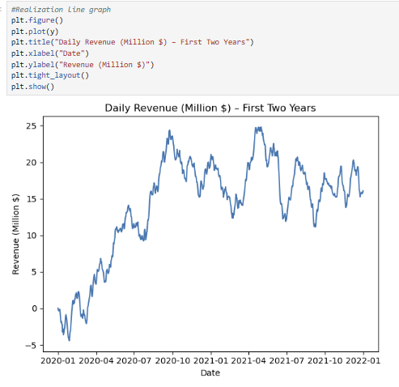
C2. The time series is structured with a daily time step, where each observation represents hospital revenue for a single day. The data span a continuous two-year period and include 731 daily revenue observations, beginning on Day 1 and ending on Day 731. To verify the consistency of the time index, the day sequence was examined to ensure that all expected daily observations were present. The data were then indexed to a daily frequency to confirm that no gaps existed in the measurement period. This process ensured that the time series maintained a continuous daily structure, which is required for time series modeling and accurate interpretation of trends and seasonal patterns.
C3. To determine whether the daily revenue data were suitable for time series modeling, the stability of the series over time was examined using a unit root test. When the test was applied to the original revenue values, the results showed that the series changed systematically over time rather than fluctuating around a constant level, indicating that it was not stationary in its raw form. To correct for this behavior, the revenue series was adjusted by calculating day-to-day changes, which removed the long-term movement present in the data. Reapplying the test to the adjusted series showed that this transformation successfully stabilized the data, making it appropriate for ARIMA-based modeling. This step ensured that the underlying assumptions required for reliable forecasting were met before proceeding with model estimation.
C4. To prepare the data for time series analysis, the dataset was first loaded and sorted by the Day variable to ensure that observations were in the correct chronological order. Data types were reviewed and converted as necessary to confirm that the day values were treated as numeric and that revenue values were properly formatted for analysis. A daily DateTime index was then created to represent the true temporal spacing of the observations and to support time series operations. The dataset was examined for missing days and missing revenue values to verify the continuity and completeness of the daily measurements. Stationarity was assessed by examining whether the revenue series maintained consistent behavior over time and whether a transformation was required to stabilize the data before forecasting. After addressing stationarity, the observations were organized in chronological order and separated so that earlier values informed model estimation, while the most recent portion of the series was retained for evaluation. In this process, the first 641 days were used to fit the model, and the final 90 days were set aside to assess forecast performance. This split enables the model to be evaluated on unseen data, providing a practical forecast horizon for short-term operational planning, including budgeting, staffing, and cash flow management.
C5. The cleaned dataset has been attached.
Part IV:
D.
D1. Visual inspection of the daily revenue series indicates the presence of both trend and seasonal behavior. The line graph of the realization shows a clear upward trend during the initial portion of the time period, followed by fluctuations around a higher revenue level. This pattern is further confirmed by the decomposed time series, where the trend component captures sustained long-term growth over time. The seasonal component of the decomposition reveals recurring cyclical patterns, suggesting that revenue follows a repeating structure across the observed period. Evidence of seasonality is also supported by the spectral density analysis, which displays prominent peaks at low frequencies consistent with long-term periodic behavior.
Autocorrelation analysis further supports these findings. The autocorrelation function (ACF) of the raw revenue series exhibits strong positive correlations across multiple lags, indicating that current revenue values are highly dependent on past observations. After first differencing, the ACF shows a rapid decline in correlation, which suggests that differencing effectively removes the trend and stabilizes the series. These autocorrelation patterns guided the selection of moving average terms in the ARIMA-based model.
The decomposed time series separates the data into trend, seasonal, and residual components, providing additional insight into the underlying structure of the revenue series. The residual component shows no clear trend when plotted over time, indicating that the major systematic patterns in the data have been captured by the trend and seasonal components. This observation is reinforced by the lack of persistent structure in the residuals, supporting the assumption that the remaining variation behaves like random noise. Together, these visualizations and diagnostic analyses confirm the presence of trend and seasonality in the original series and validate the suitability of ARIMA-based modeling for forecasting daily hospital revenue.
D2. Based on the observed characteristics of the time series, a seasonal ARIMA model was selected to account for both trend and seasonality in the daily revenue data. Decomposition of the series revealed a clear long-term trend and a repeating seasonal pattern, supporting the use of differencing at both the non-seasonal and seasonal levels. Autocorrelation analysis further informed model selection, as the ACF of the differenced series showed a pattern consistent with a moving average structure, indicating the inclusion of MA terms. To determine the most appropriate model specification, a small grid search was conducted across candidate SARIMA models, and Akaike’s Information Criterion (AIC) was used to compare model fit while penalizing unnecessary complexity. The model with the lowest AIC was SARIMA(0,1,3)×(0,1,0,365), which incorporates first-order non-seasonal differencing to address trend and seasonal differencing at an annual period to account for recurring patterns in the data (Akaike, 1974). This model was selected as it best balances explanatory power and parsimony and aligns with the observed behavior of the time series.
D3. Using the SARIMA(0,1,3)×(0,1,0,365) model identified in Part D2, a forecast was generated for the next 90 days, corresponding to the designated test horizon. The forecasting output provided an expected revenue value for each day in the projection period, accompanied by upper and lower bounds that reflect the range of plausible outcomes given the variability in the historical data. The predicted mean provides an estimate of expected revenue based on historical patterns, while the prediction interval reflects the range within which future observations are likely to fall with a high level of confidence. This approach supports both point estimation and uncertainty assessment, enabling informed short-term planning and evaluation of forecast reliability.
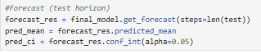
D4.
- ADF output
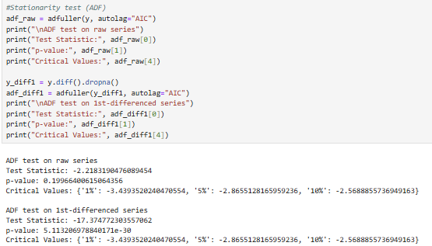
- model summary
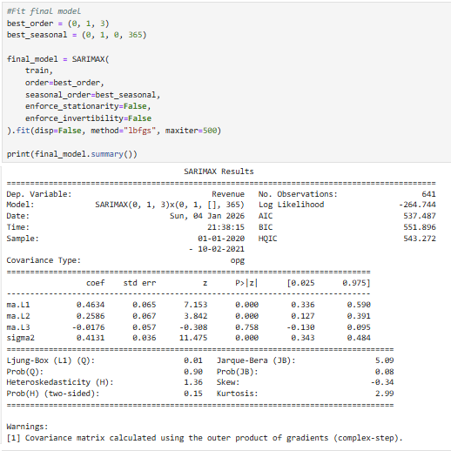
- AIC for the chosen model
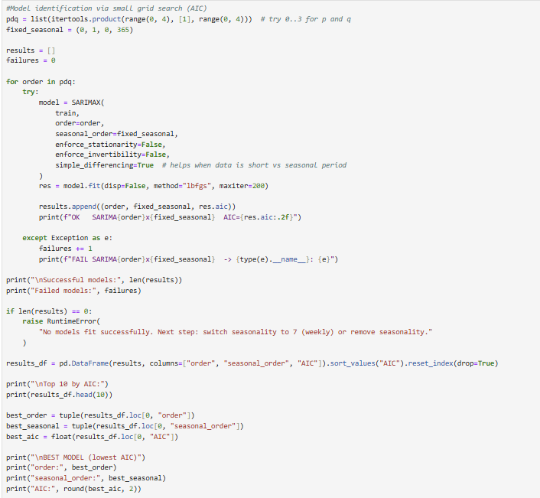
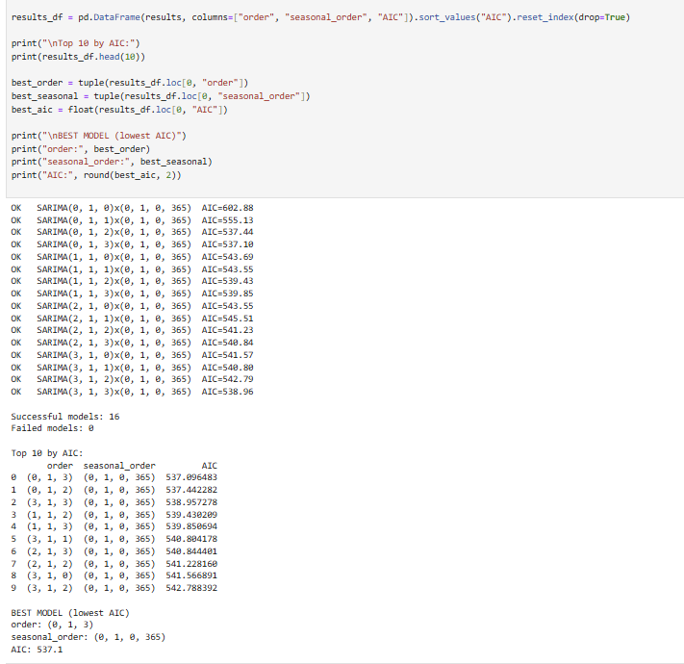
- MAE/RMSE calculations
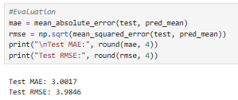
- forecast table (head/tail)
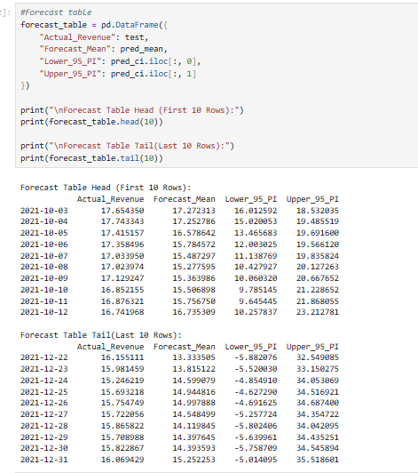
D5. Provide the code used to support the implementation of the time series model.
The code has been attached.
Part V:
E.
E1. The final model selected for this analysis was a SARIMA(0,1,3)×(0,1,0,365), which was chosen based on both statistical evidence and diagnostic evaluation. This model demonstrated the lowest Akaike Information Criterion (AIC) value among the candidate models considered, indicating an optimal balance between goodness of fit and model complexity. The inclusion of first-order non-seasonal differencing accounts for the non-stationary trend observed in the revenue series, while seasonal differencing at an annual period captures recurring long-term seasonal patterns identified through decomposition and spectral analysis. Diagnostic results further supported this selection, as residuals exhibited no significant autocorrelation and showed no remaining trend, suggesting that the model adequately captured the underlying structure of the data.
The forecast generated by the model includes a 95% prediction interval, which represents a realistic range within which future daily revenue values are expected to fall. This interval reflects the inherent uncertainty in forecasting and widens over time, as expected, indicating increasing uncertainty further into the forecast horizon. In some instances, the lower range of the forecast extends into negative values; however, these results reflect model variability rather than realistic revenue expectations and should be viewed only as an indication of uncertainty.
The forecasting window was intentionally limited to three months so that the results remain practical for short-range financial and operational planning while avoiding the increasing instability that accompanies longer forecasting periods. This time frame is practical for hospital leadership, as it aligns with short-term budgeting cycles, staffing decisions, and cash flow management, and avoids the reduced reliability associated with longer-range forecasts. Model performance was evaluated using a holdout test set consisting of the final 90 days of observed data, allowing for an objective assessment of forecast accuracy on unseen observations. Forecast accuracy was measured using mean absolute error and root mean squared error, which provide complementary perspectives on average forecast deviation and sensitivity to larger errors. Together, these evaluation results indicate that the selected model produces reasonably accurate and operationally useful forecasts for short-term revenue planning.
E2.
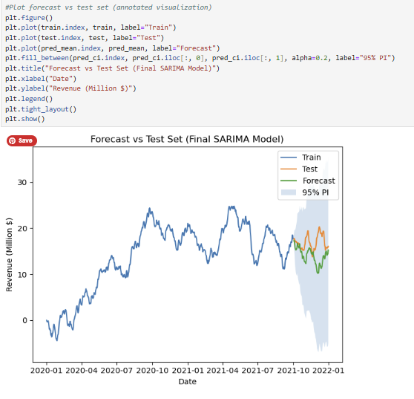
E3. Based on the results of the time series analysis, it is recommended that hospital leadership use the 90-day revenue forecast as a short-term planning tool to support budgeting, staffing, and cash flow management decisions. The selected SARIMA model demonstrates reasonable forecast accuracy over the evaluation period, making it appropriate for near-term operational use rather than long-range forecasting. Leadership should regularly compare actual daily revenue to forecasted values weekly to identify deviations early and assess whether emerging patterns differ from historical behavior. To maintain forecast reliability, the model should be re-estimated monthly as new revenue data become available, allowing the model parameters to adapt to changing conditions. If forecast errors consistently increase during specific periods characterized by unusual demand or revenue spikes, such as holiday-related or event-driven activity, additional seasonal components or alternative seasonal periods should be evaluated to better capture these effects. This approach balances practical usability with ongoing model improvement and supports data-driven decision-making.
Part VI:
F. A copy of the notebook report has been attached.
G. https://app.datacamp.com/learn/custom-tracks/custom-advanced-data-analytics
H.
Akaike, H. (1974). A new look at the statistical model identification. IEEE Transactions on Automatic Control, 19(6), 716–723. https://doi.org/10.1109/TAC.1974.1100705
Hyndman, R. J., & Athanasopoulos, G. (2021). Forecasting: Principles and practice (3rd ed.). OTexts. https://otexts.com/fpp3/
Seabold, S., & Perktold, J. (2010). Statsmodels: Econometric and statistical modeling with Python. Proceedings of the 9th Python in Science Conference. https://www.statsmodels.org
SciPy Developers. (2023). SciPy signal processing documentation. https://docs.scipy.org/doc/scipy/reference/signal.html

